**---------------------------------------------------------------------------------------------------------------------------------------**

**Name – Pawar Shrikant Sanjeev**

**SE IT**

**Roll No.47**

**CG Lab**

**Assignment No.4 :DDA Line**

**--------------------------------------------------------------------------------------------------------------------------------------**

**#include<GL/freeglut.h>**

**#include<stdlib.h>**

**#include<iostream>**

**float x1,x2,y1,y2;**

**int choice2;**

**void display(void)**

**{**

**float dy,dx,step,x,y,k,Xin,Yin;**

**dx=x2-x1;**

**dy=y2-y1;**

**if(abs(dx)> abs(dy))**

**step = abs(dx);**

**else**

**step = abs(dy);**

**Xin = dx/step;**

**Yin = dy/step;**

**x=x1;**

**y=y1;**

**glBegin(GL_LINES);//show axes**

**glVertex2f(200.0f, 0.0f);**

**glVertex2f(-200.0f, 0.0f);**

**glVertex2f(0.0f, -200.0f);**

**glVertex2f(0.0f, 200.0f);**

**glEnd();**

**glBegin(GL_POINTS);**

**glVertex2i(x,y);**

**glEnd();**

**//if((int(x) % 20) < 8)**

**//**

**if(choice2==1)**

**{**

**for (k=1 ;k<=step;k++)**

**{**

**x= x + Xin;**

**y= y + Yin;**

**if ((int(x)%2 == 0 )) //dotted**

**{**

**glBegin(GL_POINTS);**

**glVertex2i(x,y);**

**glEnd();**

**}**

**}**

**}**

**else if(choice2==2)**

**{**

**for (k=1 ;k<=step;k++)**

**{**

**x= x + Xin;**

**y= y + Yin;**

**if((int(x) % 7) < 5) //dashed**

**{**

**glBegin(GL_POINTS);**

**glVertex2i(x,y);**

**glEnd();**

**}**

**}**

**}**

**else if(choice2==3)**

**{**

**for (k=1 ;k<=step;k++)**

**{**

**x= x + Xin;**

**y= y + Yin;**

**if ((int(x)%10 <5 ) || (int(x)%10 == 7))//dash dotted**

**{**

**glBegin(GL_POINTS);**

**glVertex2i(x,y);**

**glEnd();**

**}**

**}**

**}**

**else if(choice2==4) //SOLID LINE**

**{**

**for (k=1 ;k<=step;k++)**

**{**

**x= x + Xin;**

**y= y + Yin;**

**glBegin(GL_POINTS);**

**glVertex2i(x,y);**

**glEnd();**

**}**

**}**

**glFlush();**

**}**

**void init(void)**

**{**

**glClearColor(0.7,0.7,0.7,0.7);**

**gluOrtho2D(-200,200,-200,200);**

**}**

**int main(int argc, char** argv)**

**{**

**int choice=0;**

**std::cout<<"Enter the value of x1 : ";**

**std::cin>>x1;**

**std::cout<<"Enter the value of y1 : ";**

**std::cin>>y1;**

**std::cout<<"Enter the value of x2 : ";**

**std::cin>>x2;**

**std::cout<<"Enter the value of y2 : ";**

**std::cin>>y2;**

**std::cout<<"\n Enter your choice:";**

**std::cout<<"\n 1:Dotted Line";**

**std::cout<<"\n 2:Dash Line";**

**std::cout<<"\n 3:Dash-Dotted Line";**

**std::cout<<"\n 4:Solid Line \n";**

**std::cin>>choice2;**

**glutInit(&argc, argv);**

**glutInitDisplayMode (GLUT_SINGLE | GLUT_RGB);**

**glutInitWindowSize (500, 500);**

**glutInitWindowPosition (100,100);**

**glutCreateWindow ("DDA Line Algo");**

**init();**

**glutDisplayFunc(display);**

**glutMainLoop();**

**return 0;**

**}**

**OUTPUT :**

**Enter the value of x1 : 0**

**Enter the value of y1 : 0**

**Enter the value of x2 : 100**

**Enter the value of y2 : 100**

**MENU**

**Enter your choice:**

**1:Dotted Line**

**2:Dash Line**

**3:Dash-Dotted Line**

**4:Solid Line**

**4**

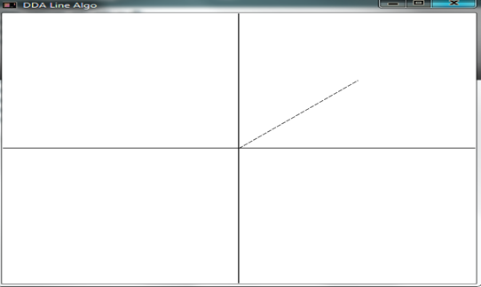

**Enter the value of x1 : 0**

**Enter the value of y1 : 0**

**Enter the value of x2 : 200**

**Enter the value of y2 : 200**

**MENU**

**Enter your choice:**

**1:Dotted Line**

**2:Dash Line**

**3:Dash-Dotted Line**

**4:Solid Line**

**1**

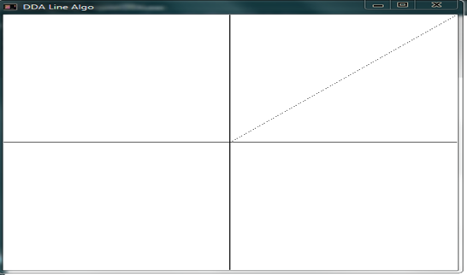

**Enter the value of x1 : 0**

**Enter the value of y1 : 0**

**Enter the value of x2 : 200**

**Enter the value of y2 : 200**

**MENU**

**Enter your choice:**

**1:Dotted Line**

**2:Dash Line**

**3:Dash-Dotted Line**

**4:Solid Line**

**2**

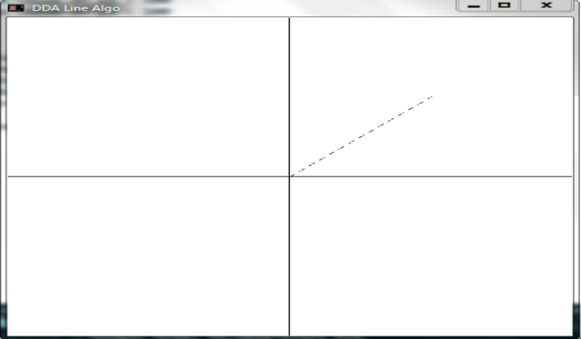

**Enter the value of x1 : 0**

**Enter the value of y1 : 0**

**Enter the value of x2 : 200**

**Enter the value of y2 : 200**

**MENU**

**Enter your choice:**

**1:Dotted Line**

**2:Dash Line**

**3:Dash-Dotted Line**

**4:Solid Line**

**3**

